Temporary Workers Personal Injury Insurance

Dear P.I.E.R Worker,
Please find enclosed a copy of Paul Ingram Employment & Recruitment Ltd.’s current insurance that is provided to every temporary worker whilst completing an assignment for P.I.E.R.
Please be aware that you will only be covered by our insurance during your time on an assignment with Paul Ingram Employment & Recruitment Ltd. The insurance policy will cease to run when you leave site for P.I.E.R. or your assignment ends.
Should you need to make a claim using Paul Ingram Employment & Recruitment Ltd.’s insurance please contact the office where someone will be more than happy to run through the process of making a claim with you.
Should you have any issues please don’t hesitate to contact us on 01446 688886.

Thank you.
Paul Ingram Employment & Recruitment Ltd

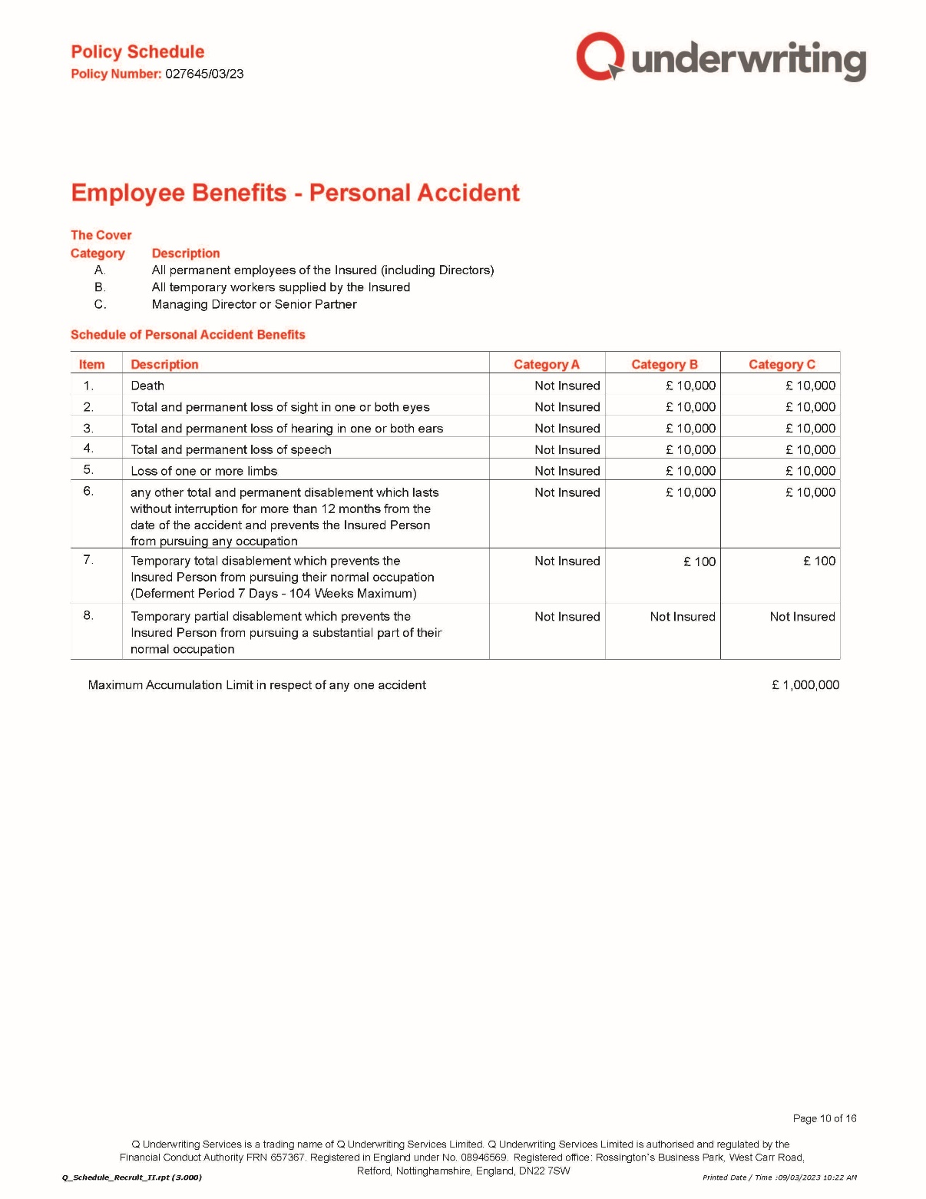

Signed:
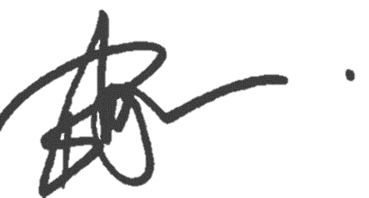
Paul Ingram
Managing Director
(28/03/2023)

